**System-User Manual**

**Version 1.2**

**Project Management App**

**Team A**

**CSC-355**

**Spring 2016**

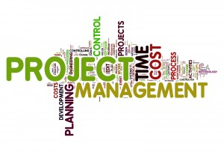

04/20/2016

Author: Jennifer Li – Project Leader

Submitted To: Dr. Joo Tan

**TABLE OF CONTENTS**

Revision History…………………………………………………………………………………..ii

1.0 Pre-Installation Requirements …..…..…..………….…...…………………………….……....1

2.0 Installation ………………...…..……………………………………………………………1-5

3.0 Using Project Management App ……………………………………………………………...6

3.1 Create an Account……………………………………………………………………..6

3.2 Login ………………………………………………………………………………….7

3.3 Create a Project ……………………………………………………………………….8

3.4 Add a Member ………………………………………………………………………..9

3.5 Accept Project Invitation ……………………………………………………………10

3.6 View all Members ……………………………………………………………….......11

3.7 Remove a Member …………………………………………………………………..12

3.8 Assign a Task ………………………………………………………………………..13

3.9 Submit a Task ……………………………………………………………………….14

3.10 Review a Task ……………………………………………………………………...15

3.11 View Calendar ……………………………………………………………………..16

3.12 View Overall Progress ……………………………………………………………..17

3.13 View Individual Progress ………………………………………………………......18

3.14 Choose a Role ……………………………………………………………………...19

3.15 Set a Reminder ……………………………………………………………………..20

3.16 Message a Member ………………………………………………………………...21

3.17 Logout ………………………………………………………………………….......22

**REVISION HISTORY**

|  |  |  |  |
| --- | --- | --- | --- |
| Version | Author | Description | Date |
| 1.0 | Jennifer Li | I created the first draft. | 01/31/2016 |
| 1.1 | Jennifer Li | Added Section 1, 2 and all of section 3. | 04/07/2016 – 04/13/2016 |
| 1.2 | Jennifer Li | Edited the word image to figure in section 2 and all of the sub sections in section 3.  Caption change in section 2, 3.1, 3.2, 3.3, 3.4, 3.5, 3.6, 3.7, 3.9, and 3.10. | 4/17/2016 |
| 2.0 | Jennifer Li | Made grammatical changes in all of the sub sections in section 3.0  Added Figure 20 and 21 in section 3.15 and 3.16 | 4/19/2016 |

**1.0 PRE-INSTALLATION REQUIREMENTS**

Before installation of the Project Management app, verify the following prerequisites are met:

1. The device system must run on Android.
2. The user must have a Google Play Account to utilize the Google Play Store.
3. The minimum operating system that is needed to run the application is Android 19.

**2.0 INSTALLATION**

The following directions is an easy four step guide of how to install Team A’s Project Management application using an Android device.

**Step 1.** On your Android device click the Play Store icon to enter the Google Play Store as shown in Figure 1

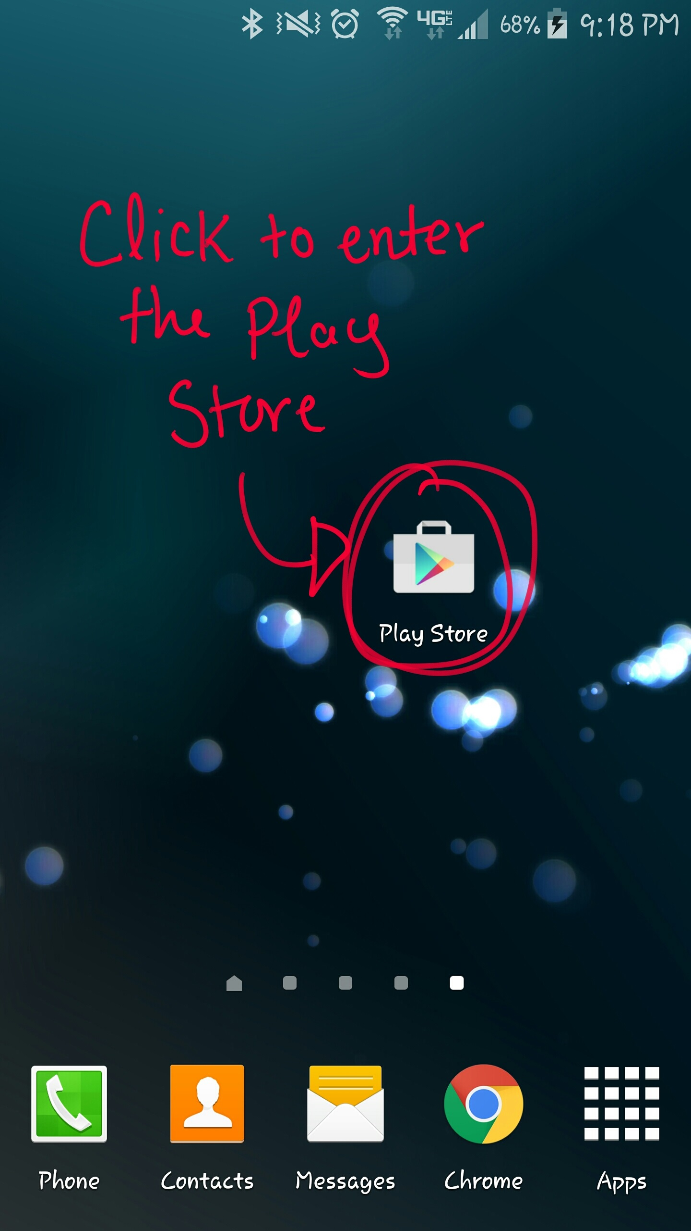

Figure 1: Google Play Store Icon

**Step 2.** After entering the Play Store, enter in the words “Kutztown Project Management” in the search bar shown in Figure 2 or click on the link down below to be directed to the application.

Link: <https://play.google.com/store/apps/details?id=com.kutztown.project.projectmanagement>

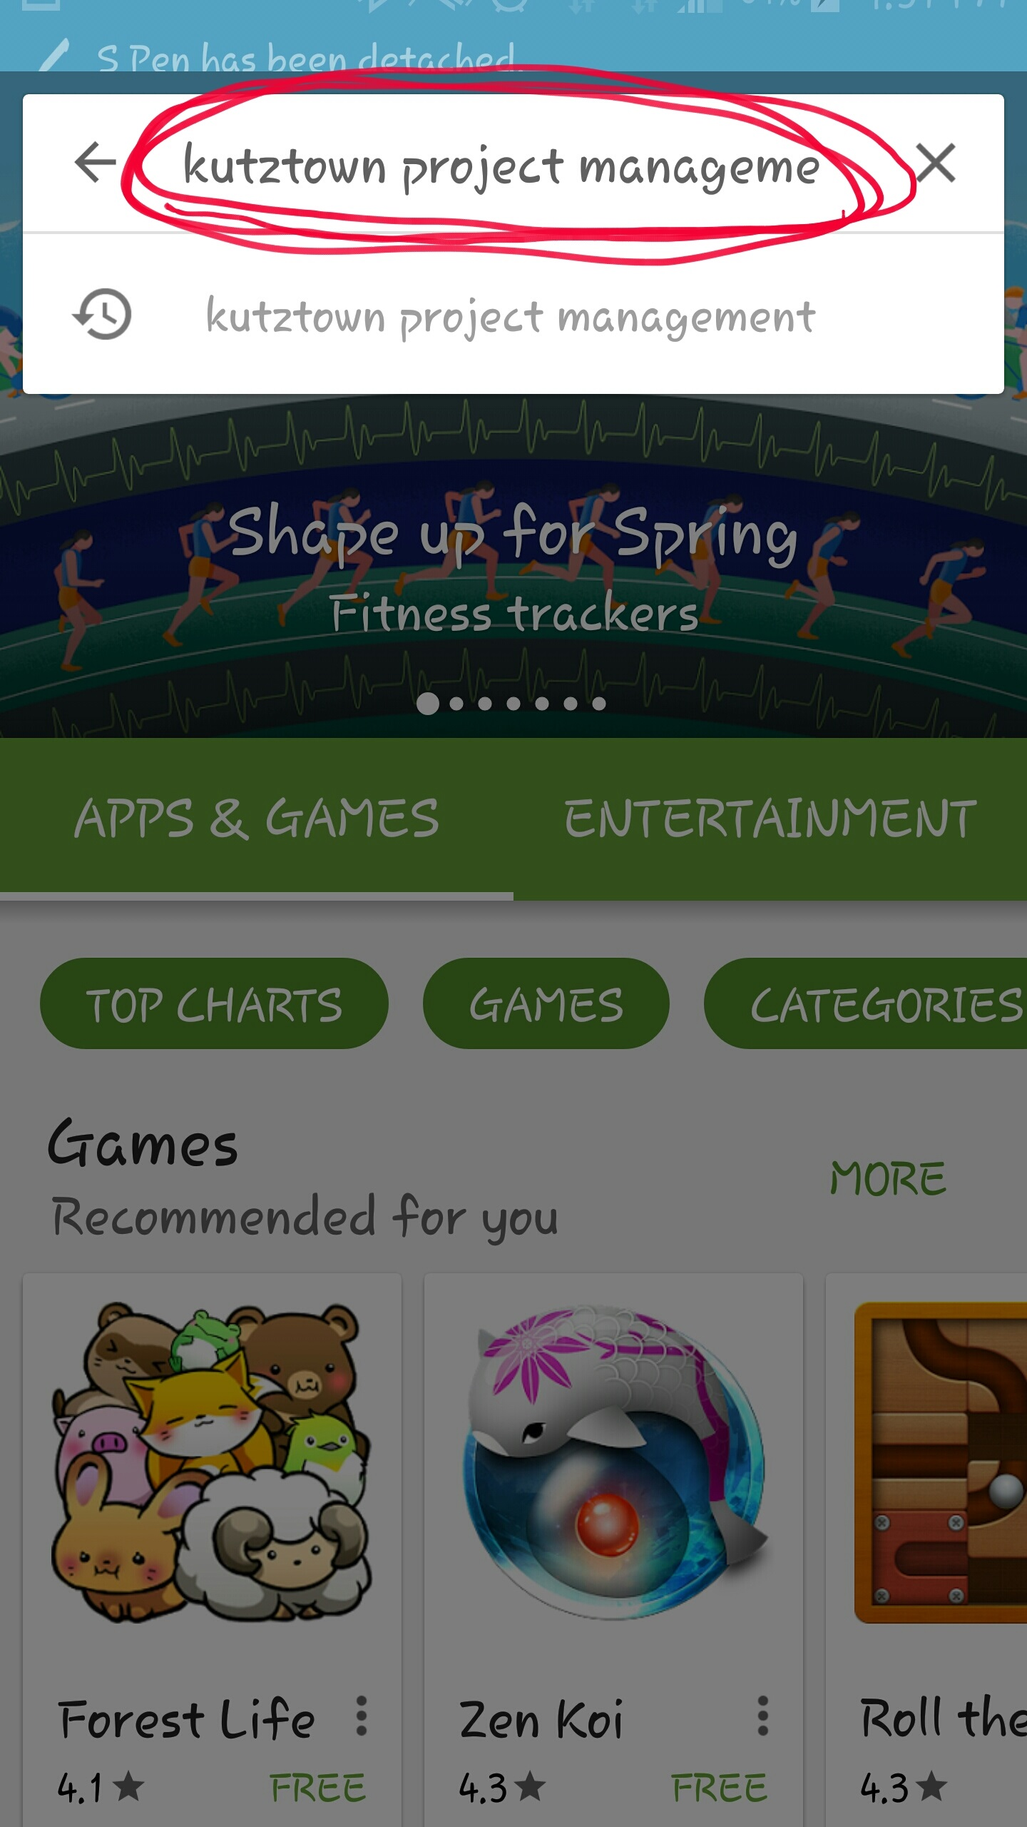

Figure 2: Search Bar containing “Kutztown Project Management”

The application’s Icon has the letters “PM” in white with a blue background shown in Figure 3

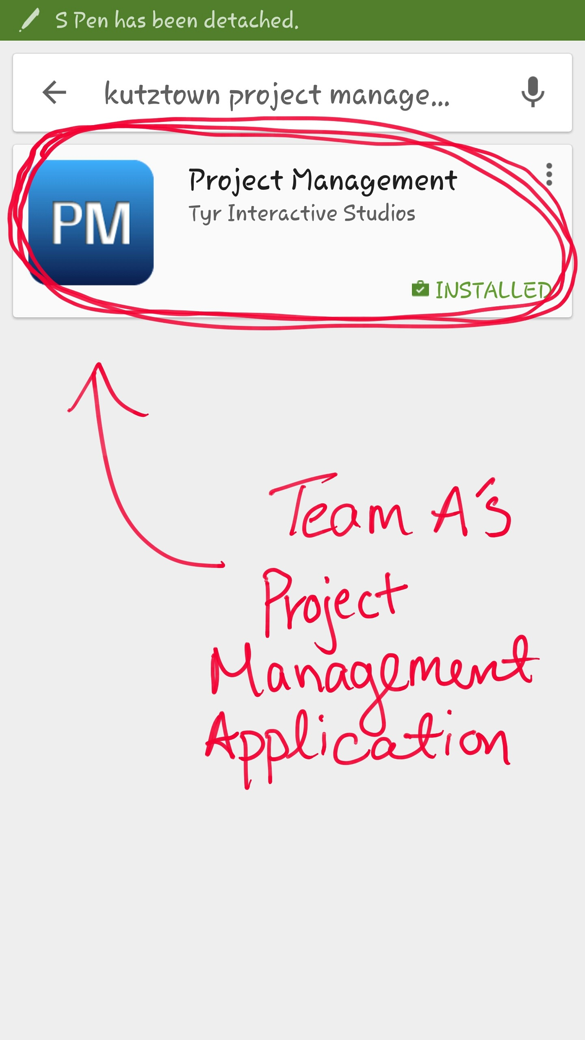

Figure 3: Project Management Icon

**Step 3.** Select the Project Management application. You will be directed to the application’s installation page. Click the “INSTALL” button as shown in Figure 4.

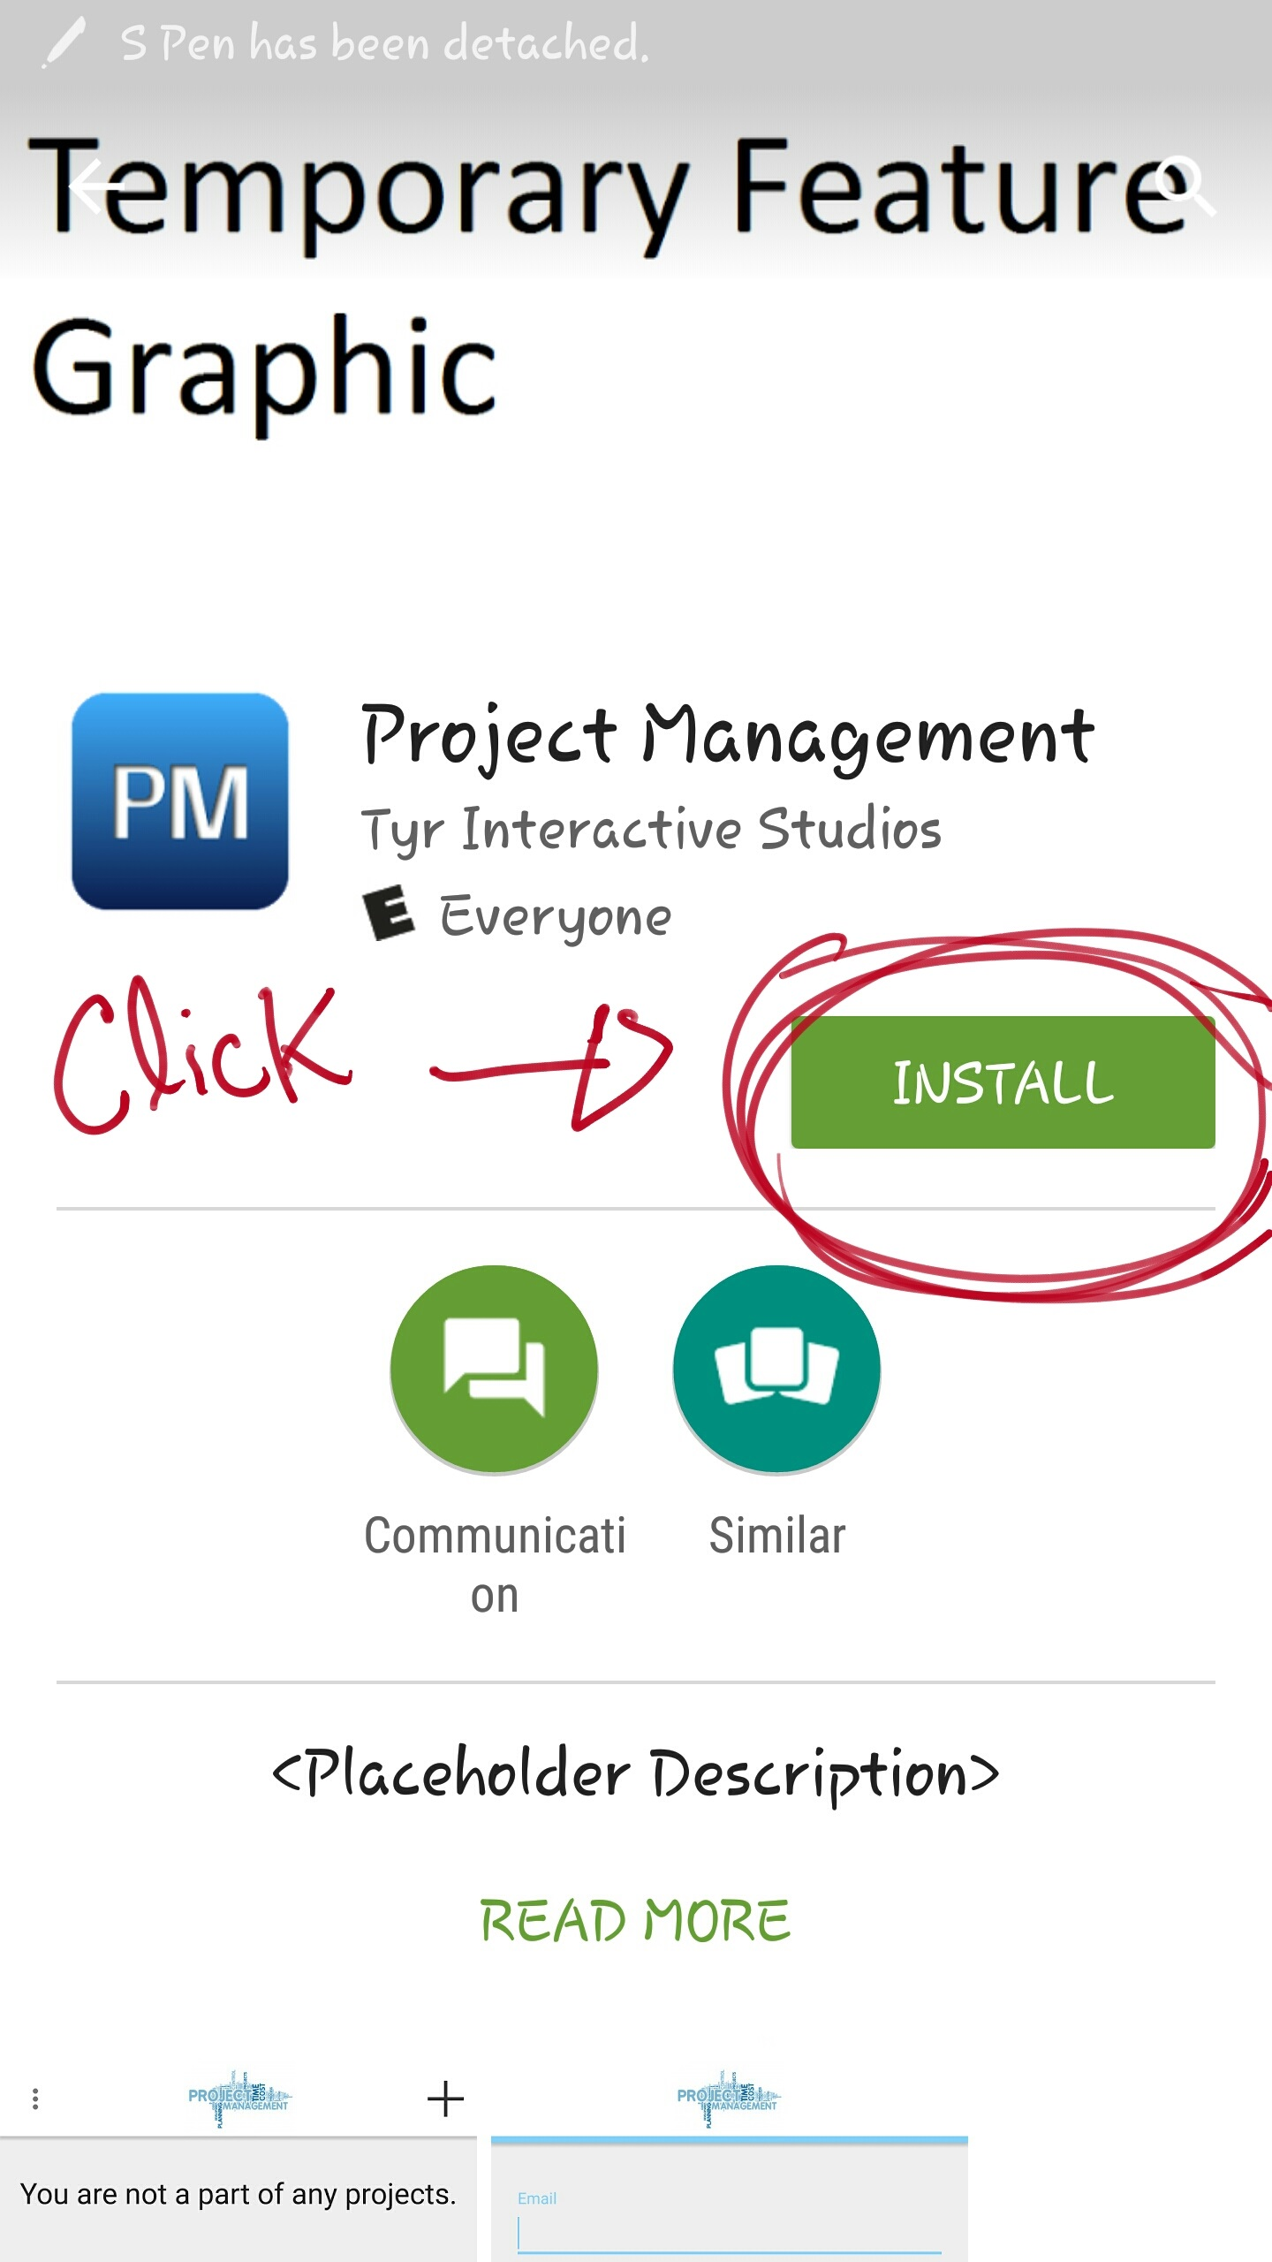

Figure 4: Installation button on the application’s installation page

**Step 4.** Accept all of the application’s needs to access and wait for the application to install on your android device. Once the application has properly installed, click the “OPEN” button shown in Figure 5.

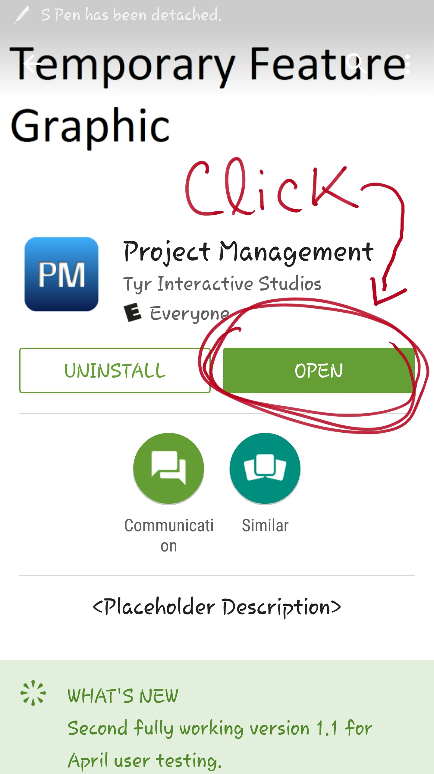

Figure 5: Open button on the application’s installation page

Congratulations! You have successfully installed Team A’s Project Management application!

**3.0 USING PROJECT MANAGEMENRT APP**

The following sections will be a simple guide of the basic functionality of the Project Management App. The apps functionality consist of, creating an account, logging in, creating a project, adding members, accepting project invitations, viewing all added members, removing members, assigning task, submitting completed task, reviewing the submitted task, viewing the calendar, viewing the overall progress, viewing individual progress, choosing a role, setting reminders, and messaging.

**3.1 Create an Account**

To create an account you must first register. All you need to do to register in this application is to enter your “Email” and “Password” in the provided fields. The entered email must be an email address, that emails can be sent to and the password must be longer than four characters. After all the fields are filled out, click the “REGISTER” button to create an account as shown in Figure 6.

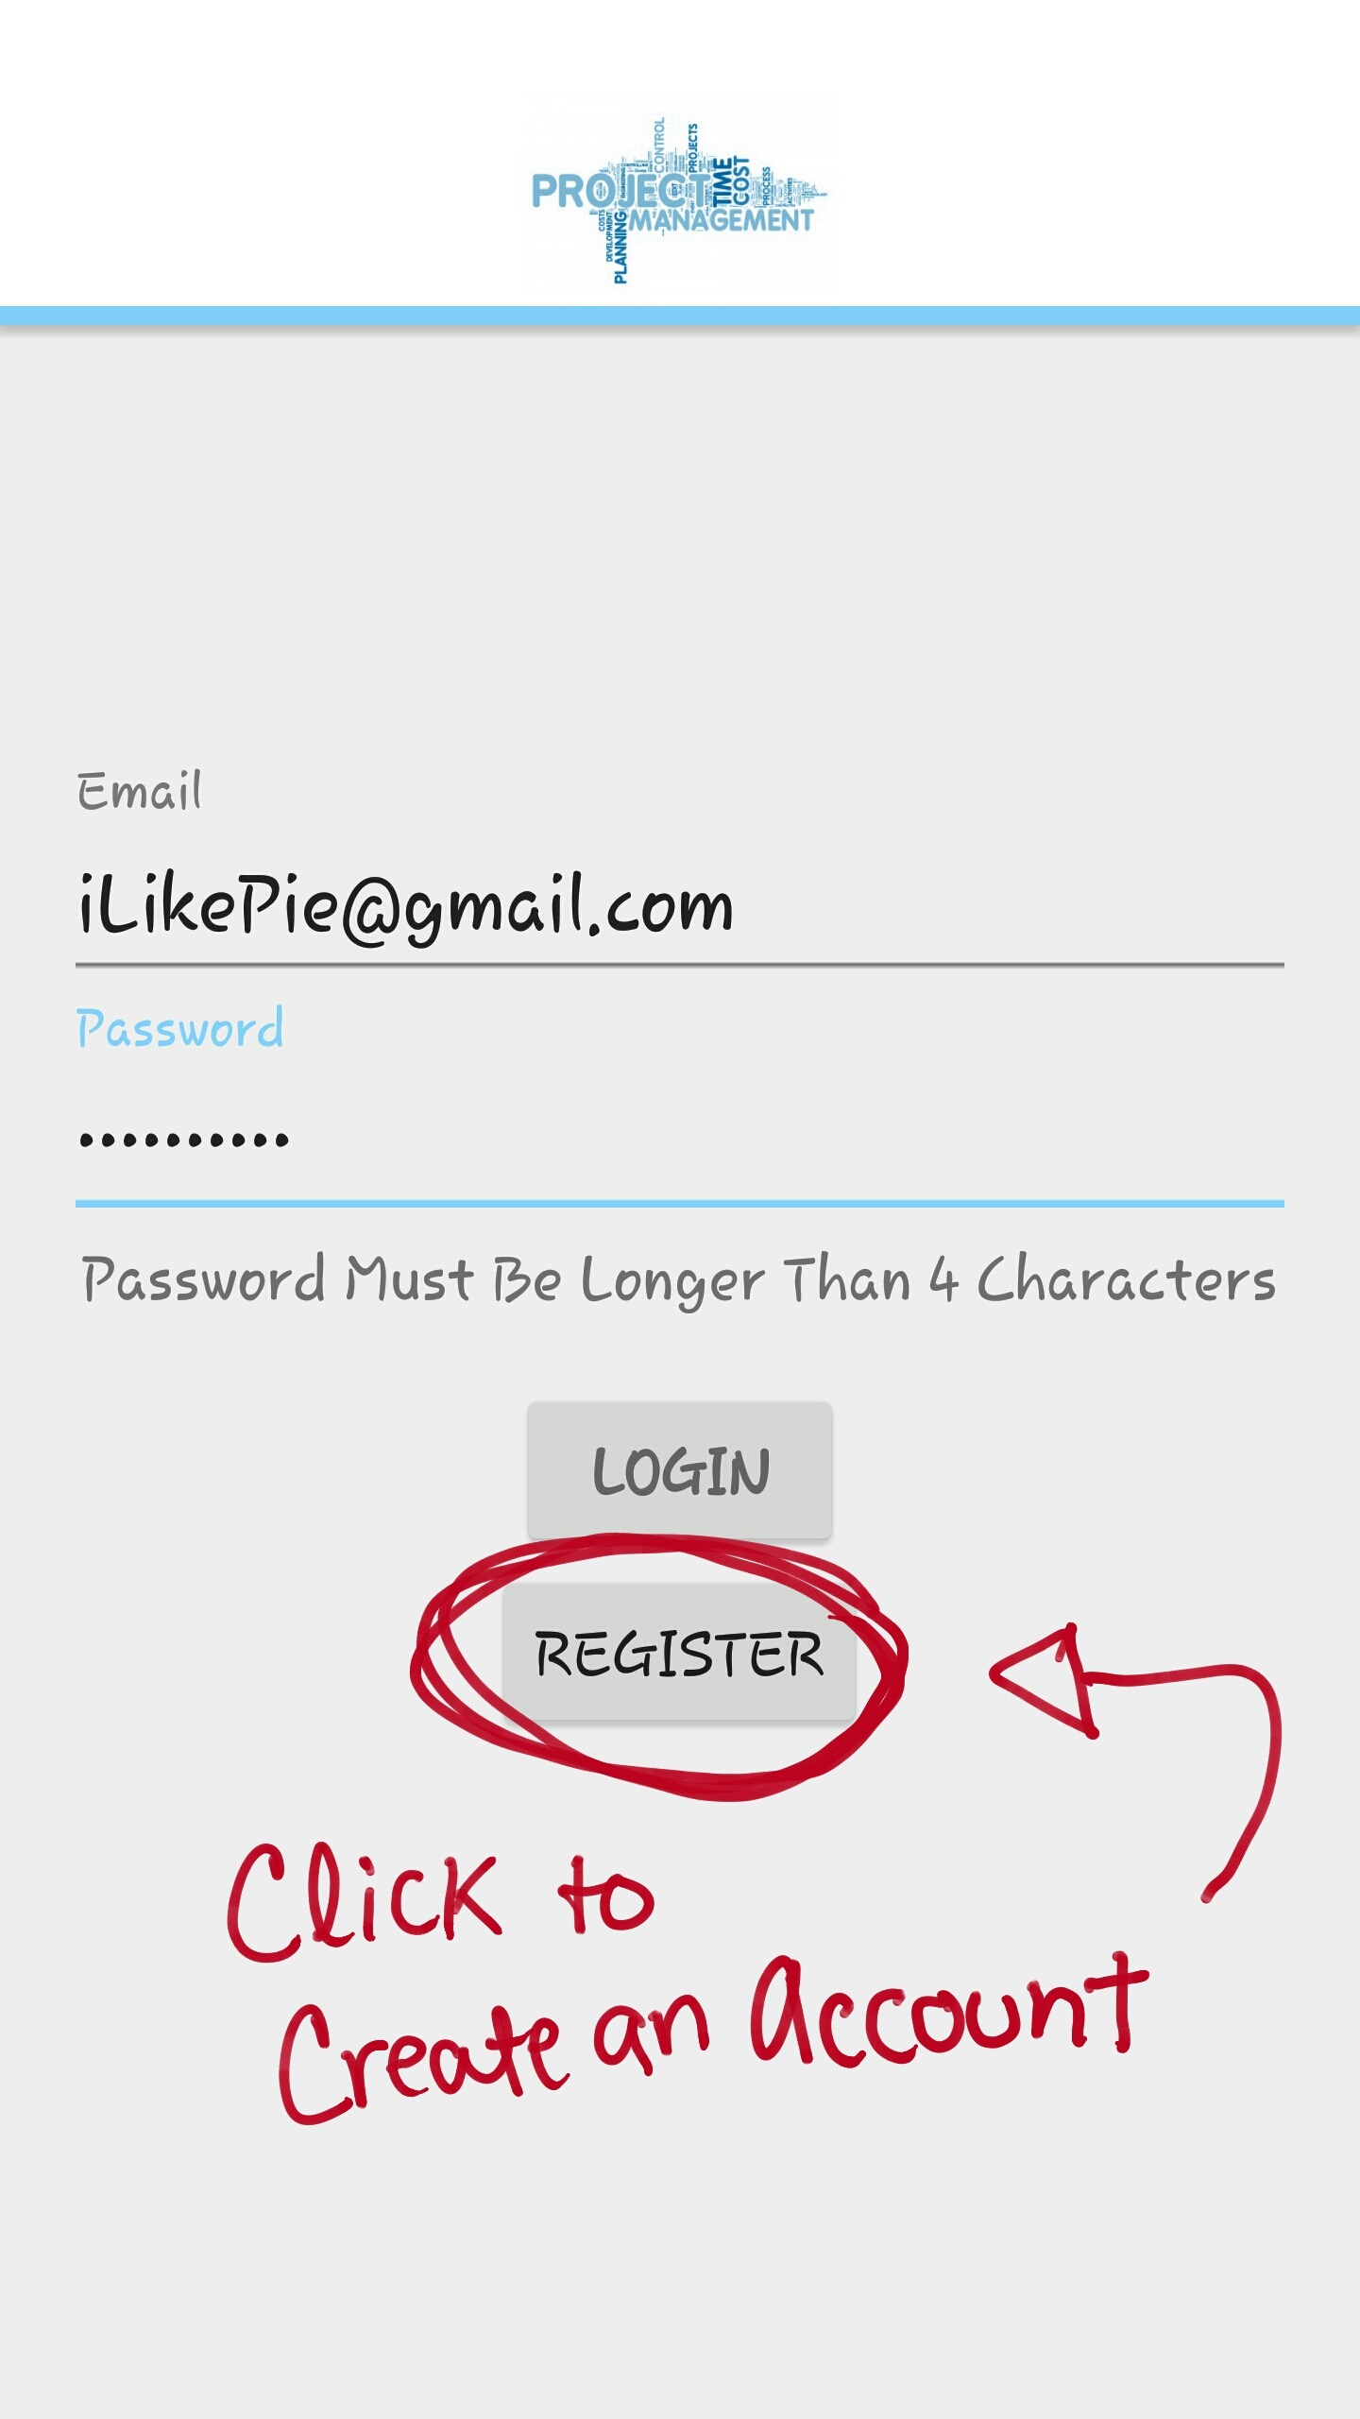

Figure 6: Register button on the application’s create an account page

**3.2 Login**

To login to the application, all you need to do is to enter your Email address and the correct password that you created. Once both fields are filled out, click the “LOGIN” button to access your account like shown in Figure 7.

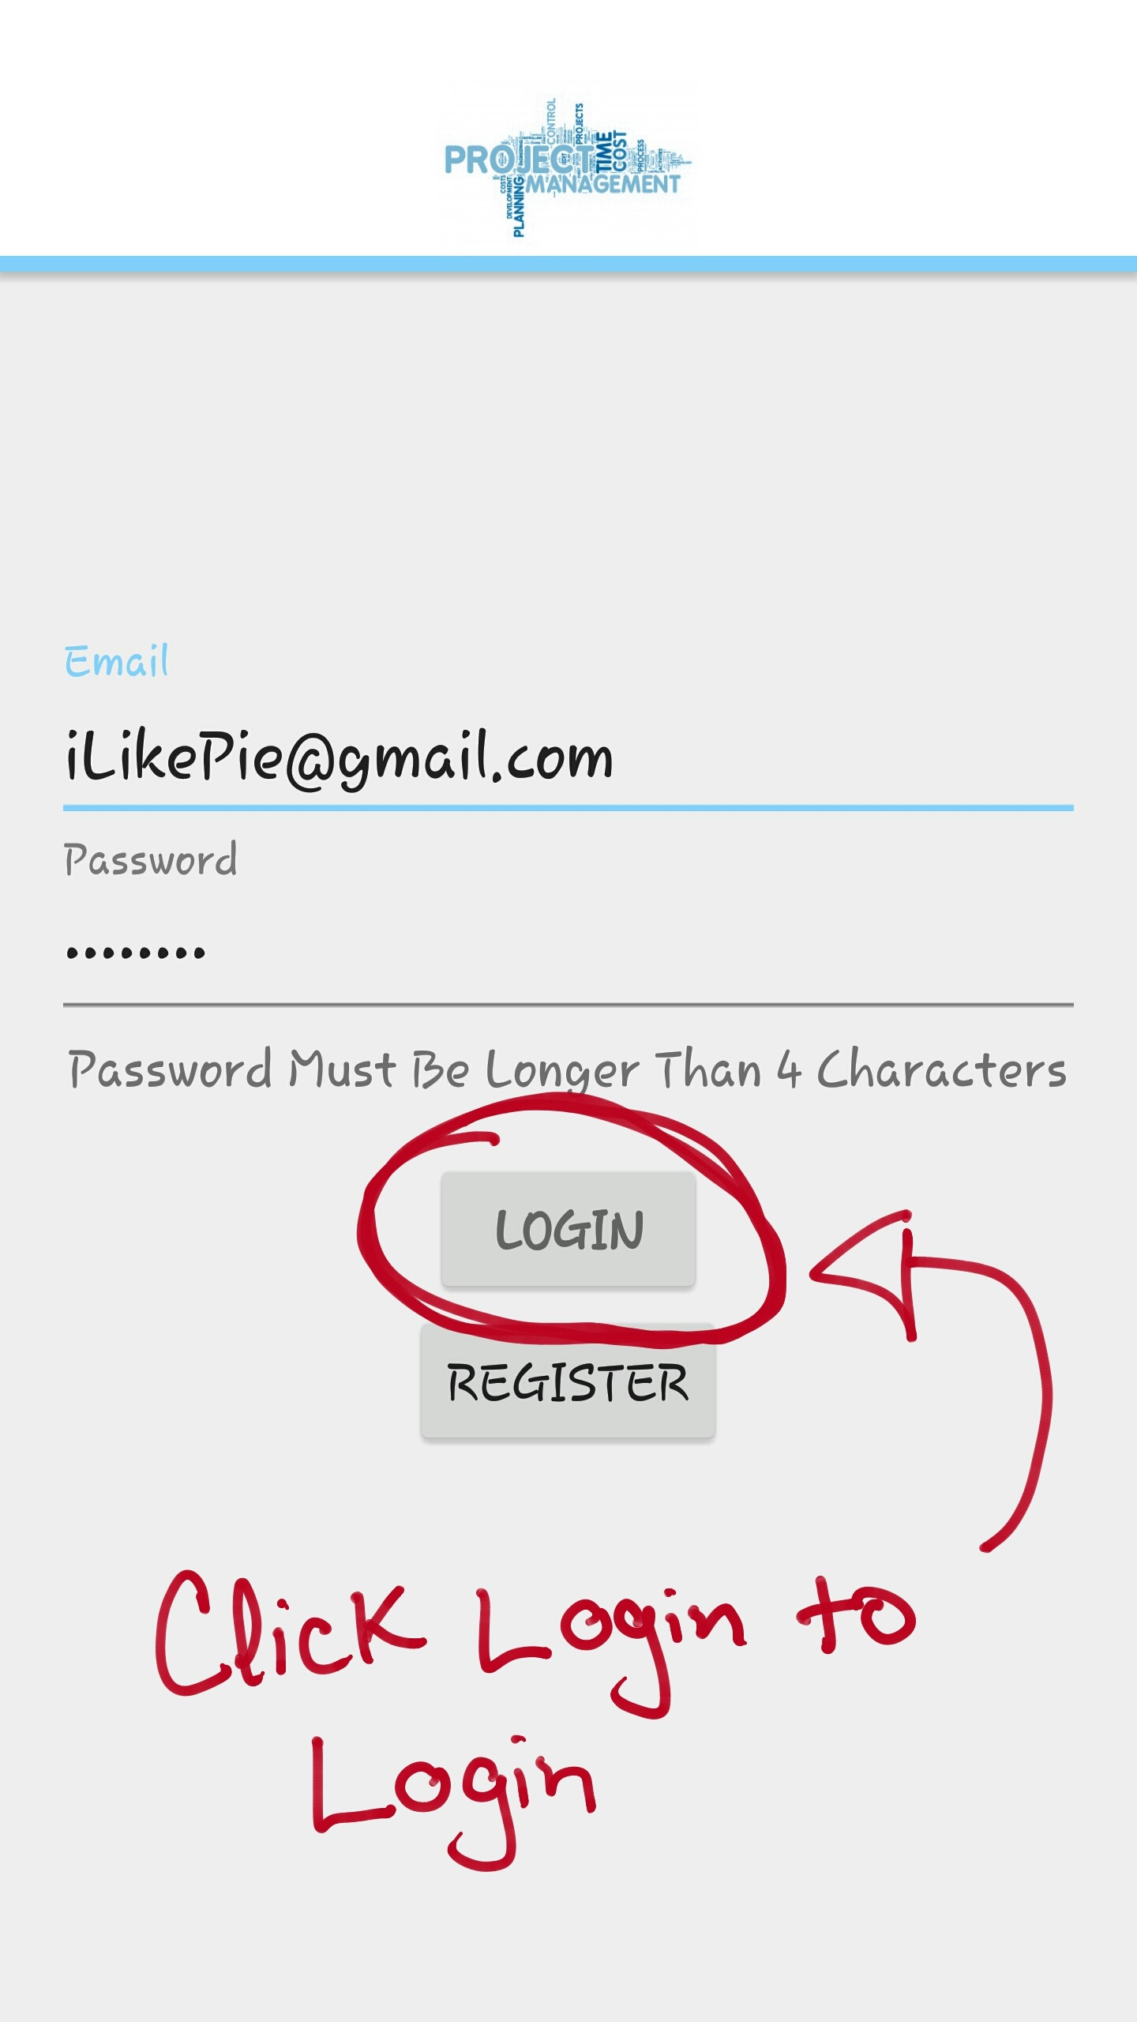

Figure 7: Login button on the application’s create an account page

**3.3 Create a Project**

After you have logged in to the application, click the “**+**” sign to create a project. Once the “**+**” is clicked, you will be directed to the create a project screen. There you will fill out the “Project Name” and “Project Description” fields. Once the fields are filled out click the “CREATE” button to create the project as shown in Figure 8.

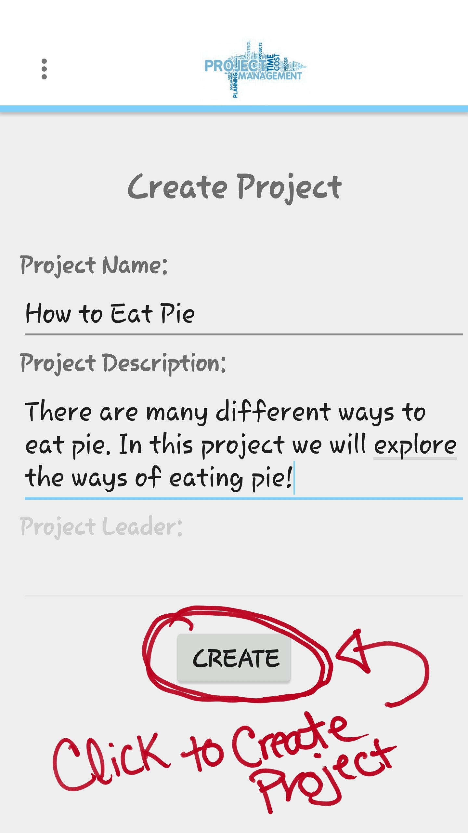

Figure 8: Create button on the application’s create a project page with all fields filled

**3.4 Add a Member**

Once you have logged in and created a project; the next step is to add a member to the project. To add a member to a project, click the “MEMBERS” button at the bottom right of the project view screen. You will then be directed to the member list view screen; there you will click the “**+**” sign. The “**+**” sign will direct you to the list of all members that have register in the database. Select the member you would like to join your project. Once the member is selected, you will be prompted to choose a mail client to email an invitation to the selected member as shown in Figure 9. After selecting a mail client, you will be directed to that mail client’s compose an email screen. There you will hit the send button to send the invitation out to the desired member.

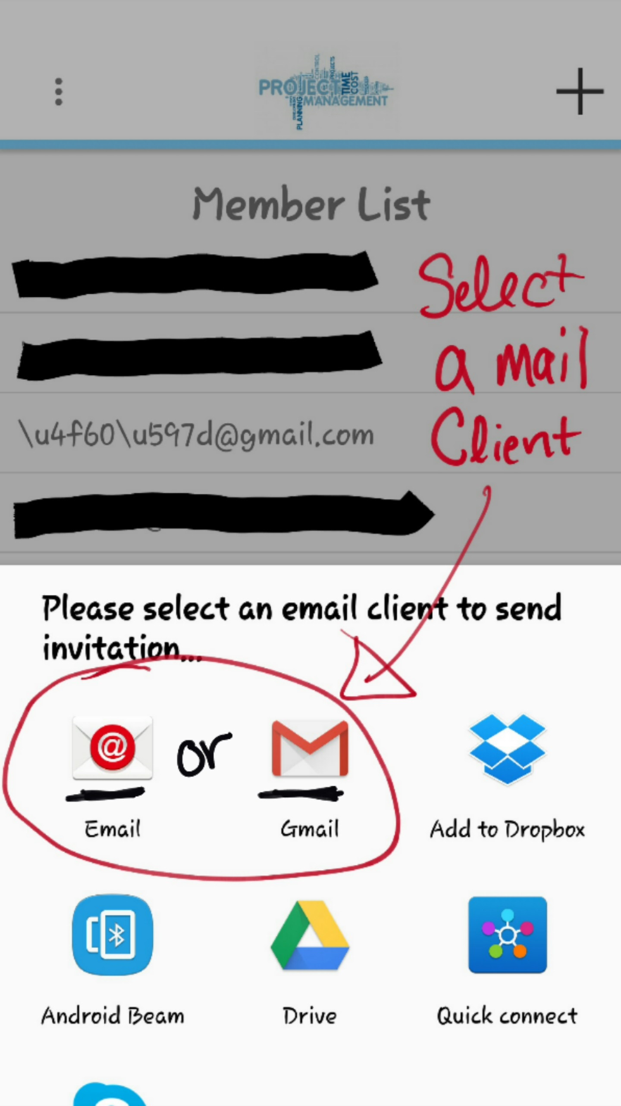

Figure 9: Android’s automatic select a mail client prompt

**3.5 Accept Project Invitation**

The invited member should have a pre-existing account to be able to receive invitations to a project. If you have been invited to join a project by the use of the Project Management app, you must first check your email to see if the invitation has been received. The sender of the email should be the name of the project leader that invited you to the project. Open up that email and click the link that has been provided. That link will take you to the web service that handles project invitations. If the web service displays a “1” you have been added into the project as shown in Figure 10.

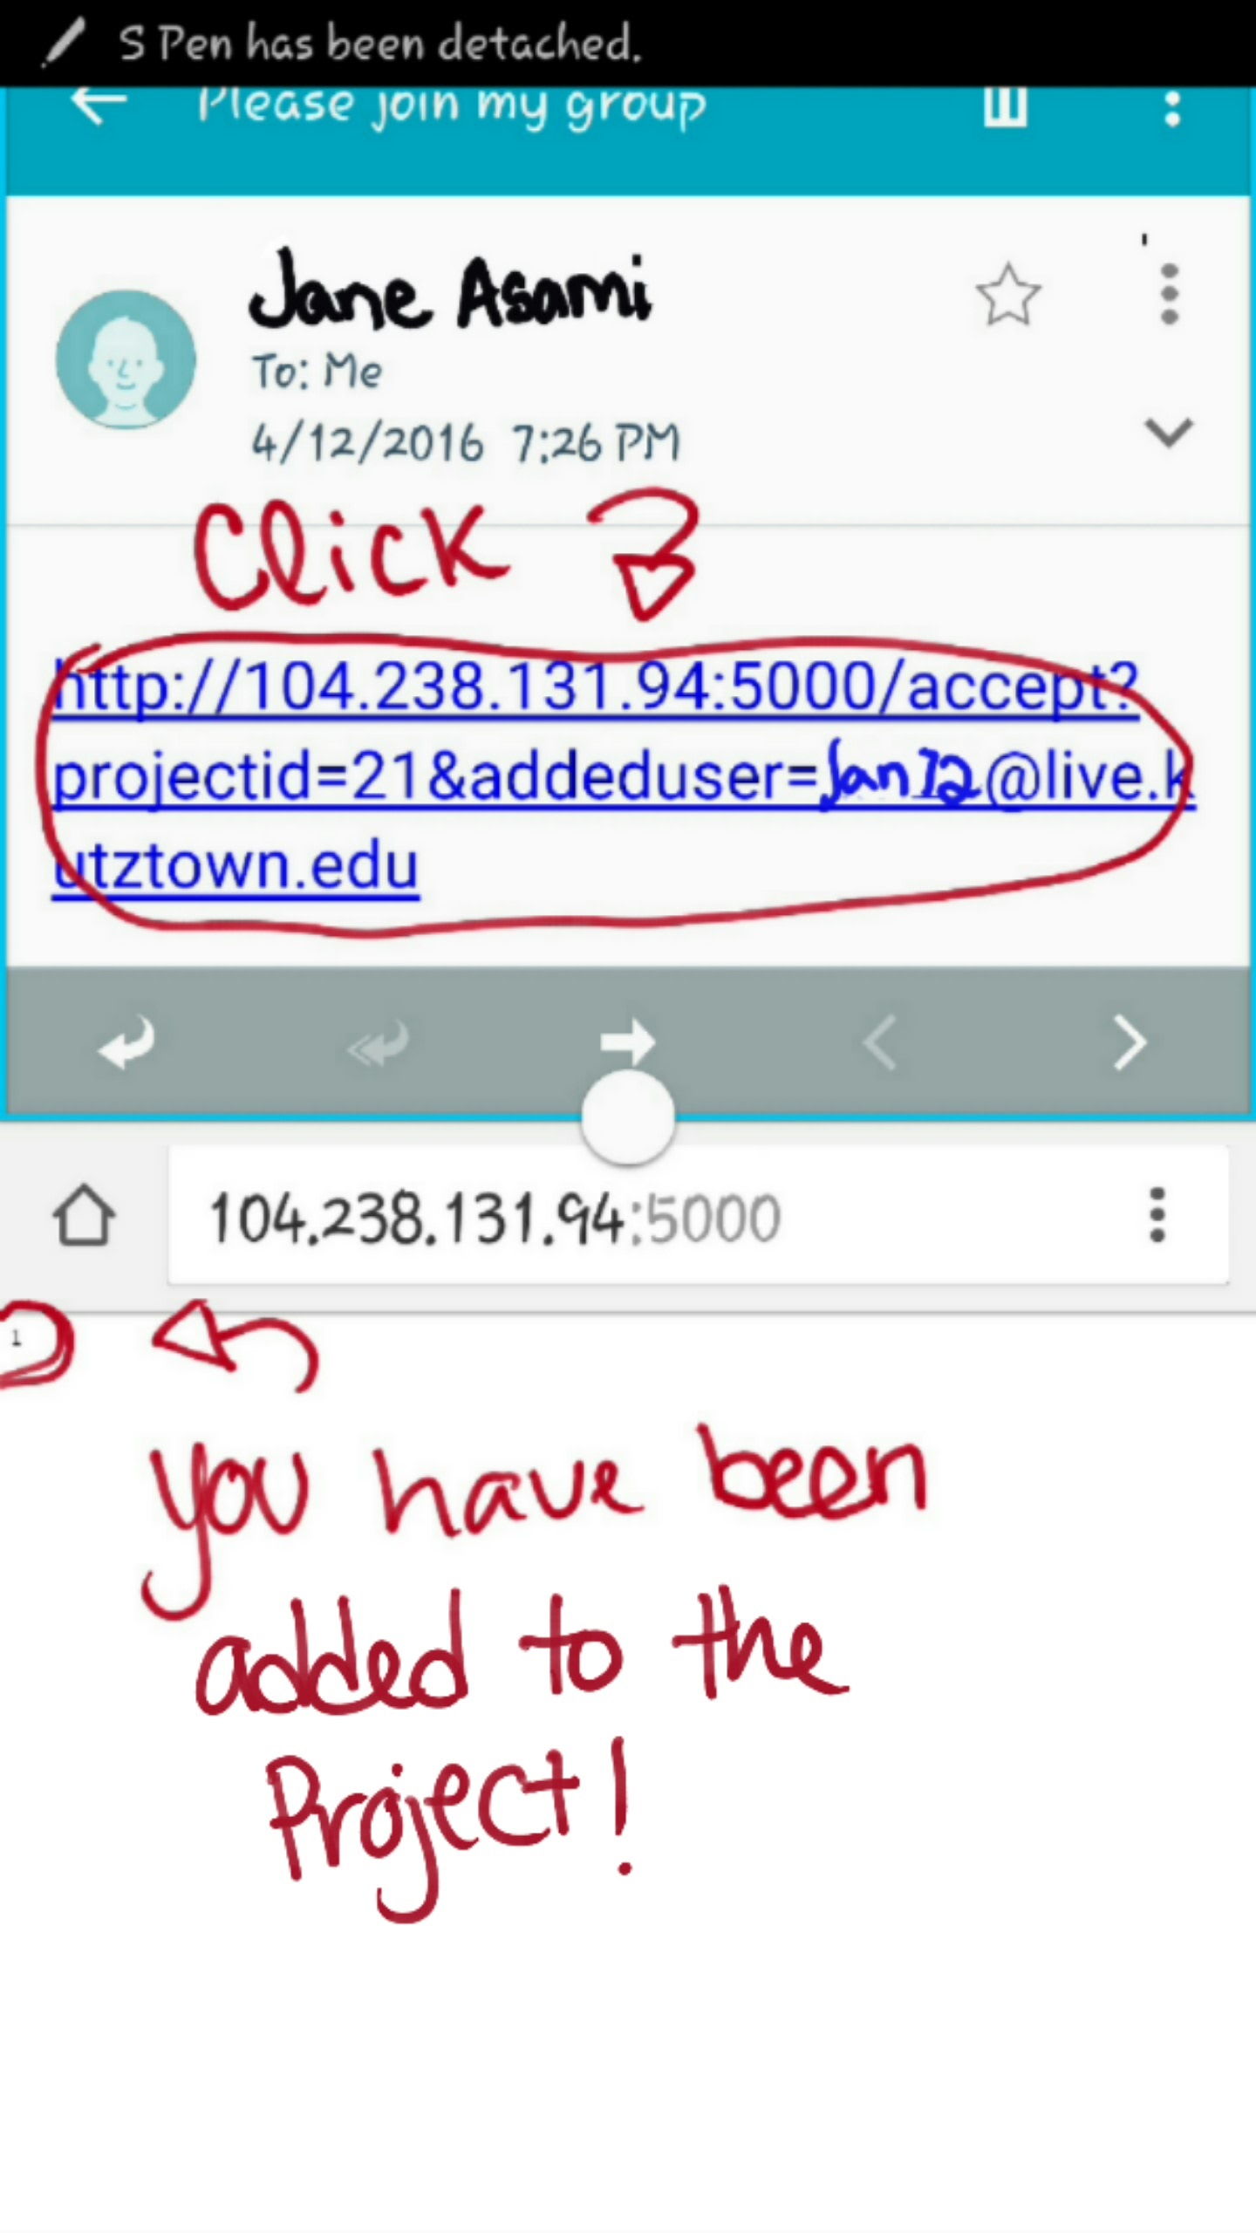

Figure 10: Received invitation from project leader and successfully added member to the project

**3.6 View all Members**

To view all members associated to a project, you have to be logged in and be a part of a created project. Once those requirements are met, click the “MEMBERS” button at the bottom right of the project view screen. You will then be directed to the Member list view screen that is shown in Figure 11.

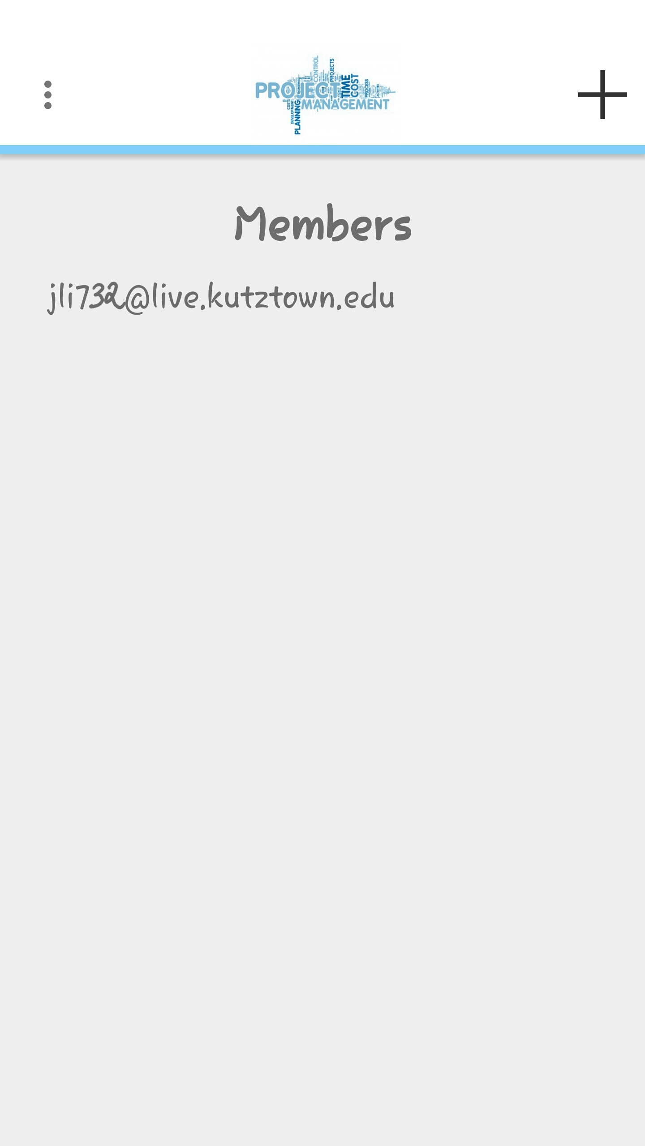

Figure 11: List of all members in the How to Eat Pie project

**3.7 Remove a Member**

To remove a member associated with a project, you have to be the leader of the created a project. Once that requirement is met, click the “MEMBERS” button at the bottom right of the project view screen. You will then be directed to the Member list view screen, select the member you would like to remove from the project by holding the click until you are prompted to remove the selected member. Next slide your finger over to the prompt and select “YES” to remove the member as shown in Figure 12.

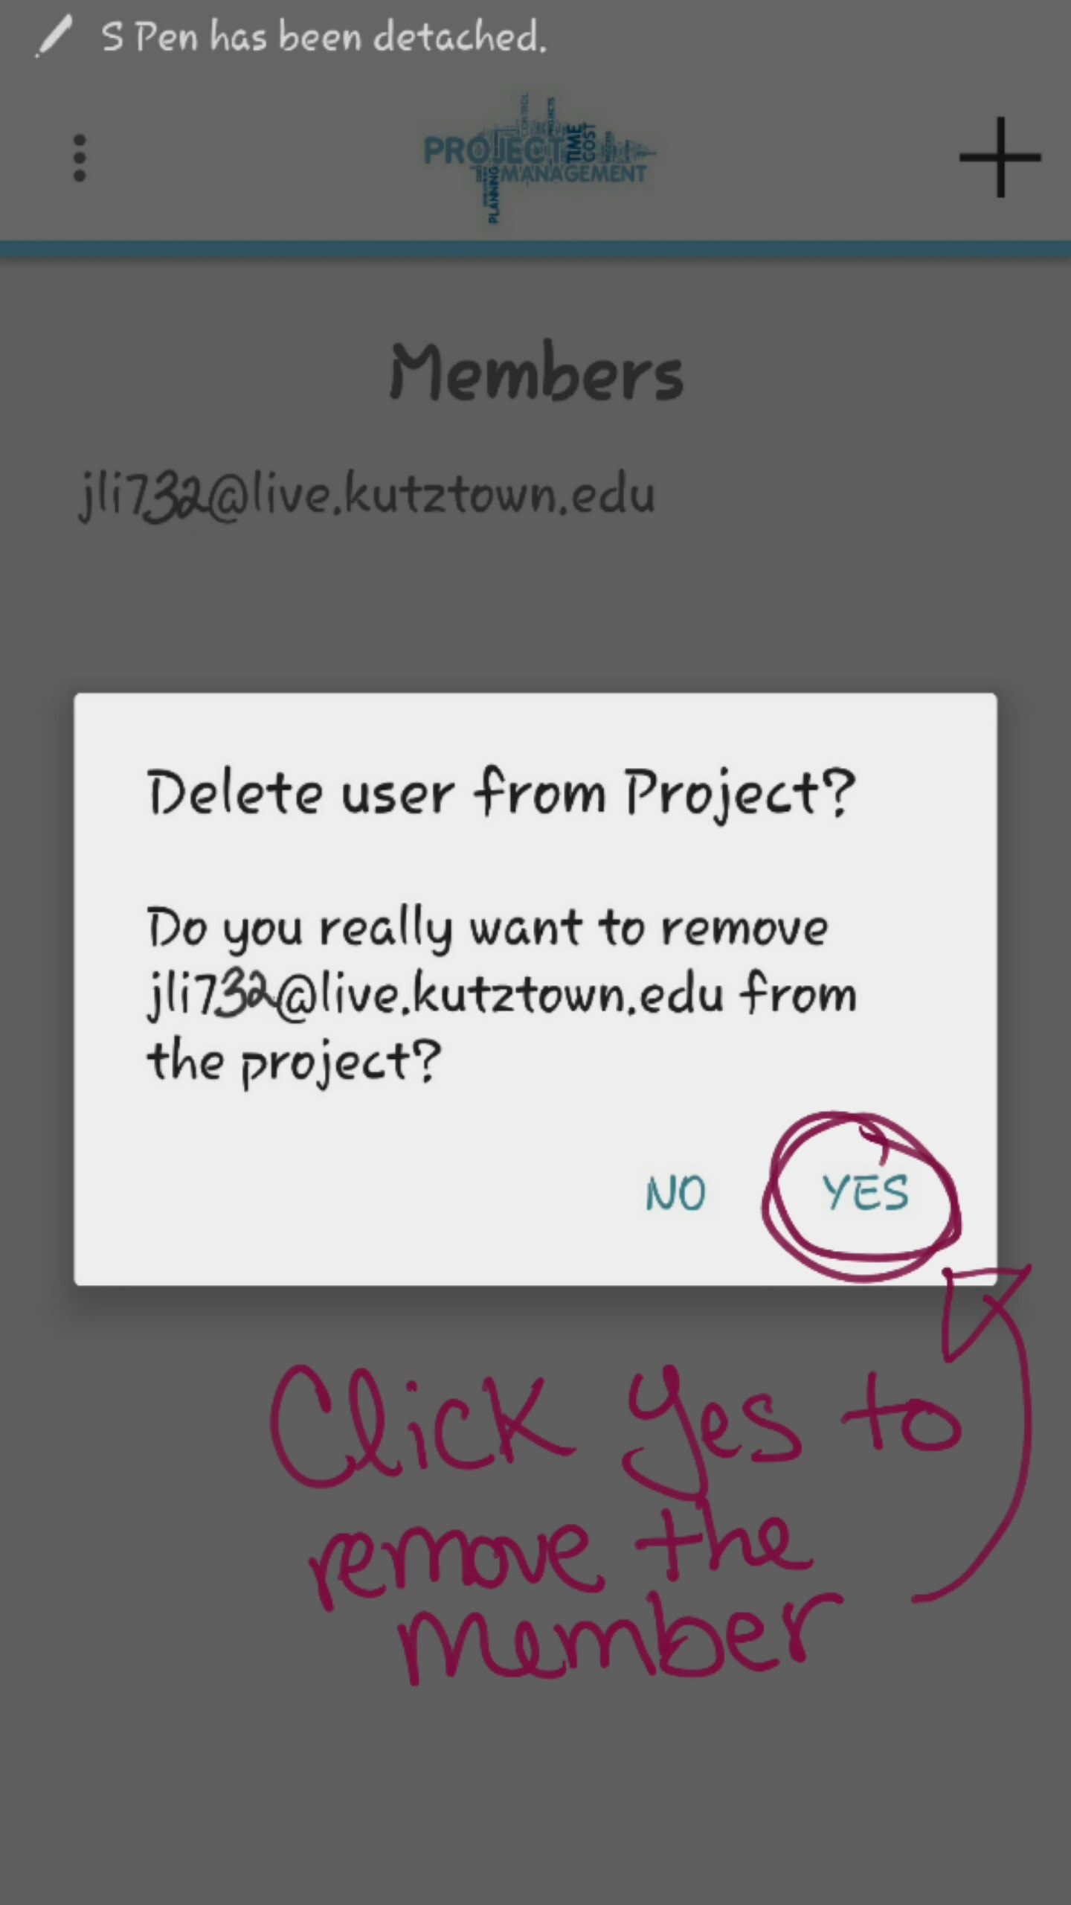

Figure 12: Android’s removing a member prompt

**3.8 Assign a Task**

Once you have logged in and have member(s) in a created project, the next step is to assign task(s) to member(s). To assign task, click the “TASK” button at the Top right of the project view screen. You will then be directed to the task list view screen; there you will click the “**+**” sign. The “**+**” sign will direct you to create a task screen, there you will fill out the necessary fields and choose a due date as shown in Figure 13. Once the fields are filled, hit create a task to be directed back to the task list view screen.

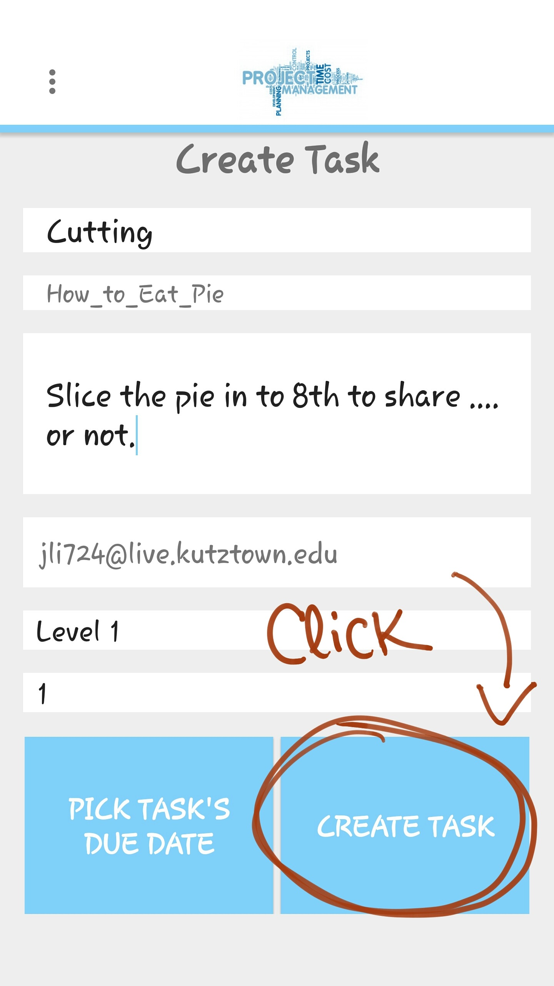

Figure 13: Leader has filled out the necessary fields and ready to create the task

**3.9 Submit a Task**

To submit a task, you must be a member of the specific project. If you are a member and have been assigned a task, click the “TASK” button at the top right of the project view screen. You will then be directed to the task list view screen. There you will select the specific task assigned to you. Preform the task and move the percentage bar to 100% to complete the task and click the “SUBMIT” button as shown in Figure 14.

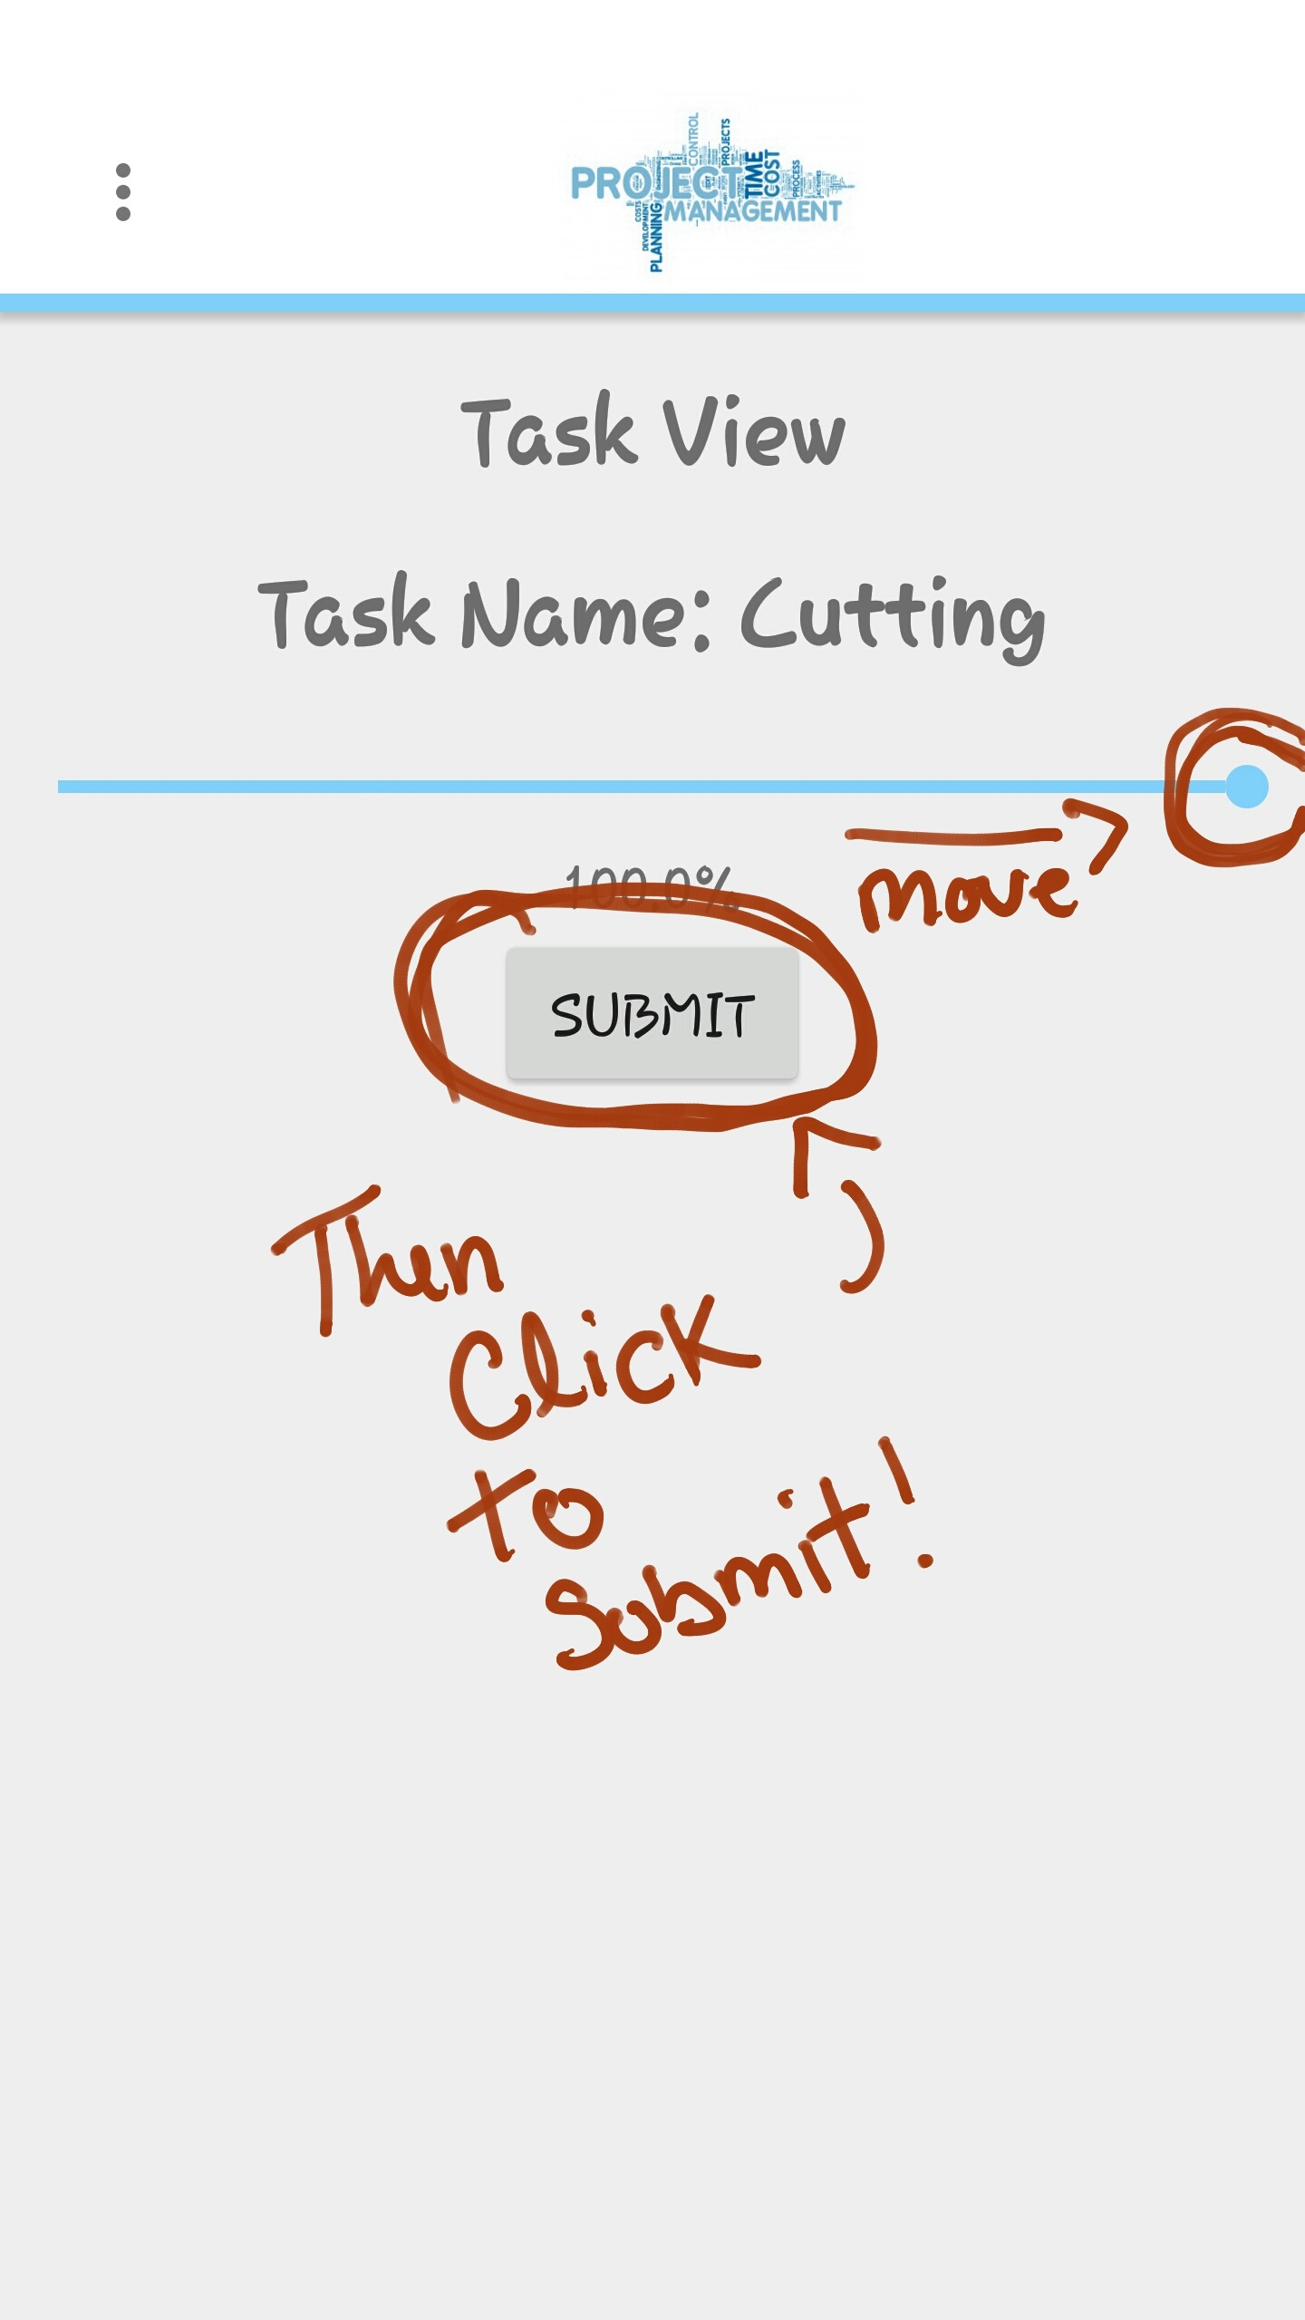

Figure 14: Task Cutting’s percentage bar is moved to 100% by member for submission

**3.10 Review a Task**

To review a task, you must be the leader of a specific project with completed task(s). If you are the leader and have a completed task in your project, click the “TASK” button at the Top right of the project view screen. You will then be directed to the task list view screen. There you will select the completed task(s) under the “Completed Tasks” section of the list. Select a specific task for review. If the task is complete leave the percentage bar be and return to the task list view screen. If the completed task is not up to your standards, move the progress bar to a desired percentage and hit update as shown in Figure 15.

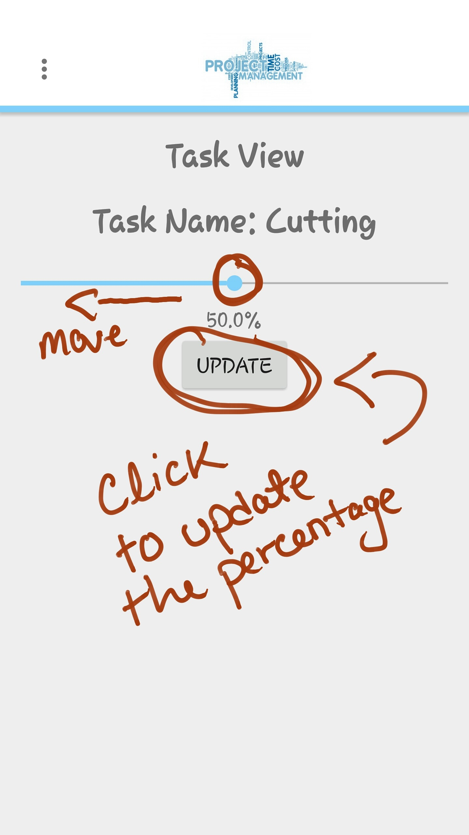

Figure 15: Task Cutting’s percentage bar is moved back to 50% by leader

**3.11 View Calendar**

To view the calendar of the specific project you must be logged in and be a part of a created project. Once those requirements are met, Click the “CALENDAR” button at the middle right hand side in the project view screen as shown in Figure 16. You will then be directed to the calendar view specific to your phone.

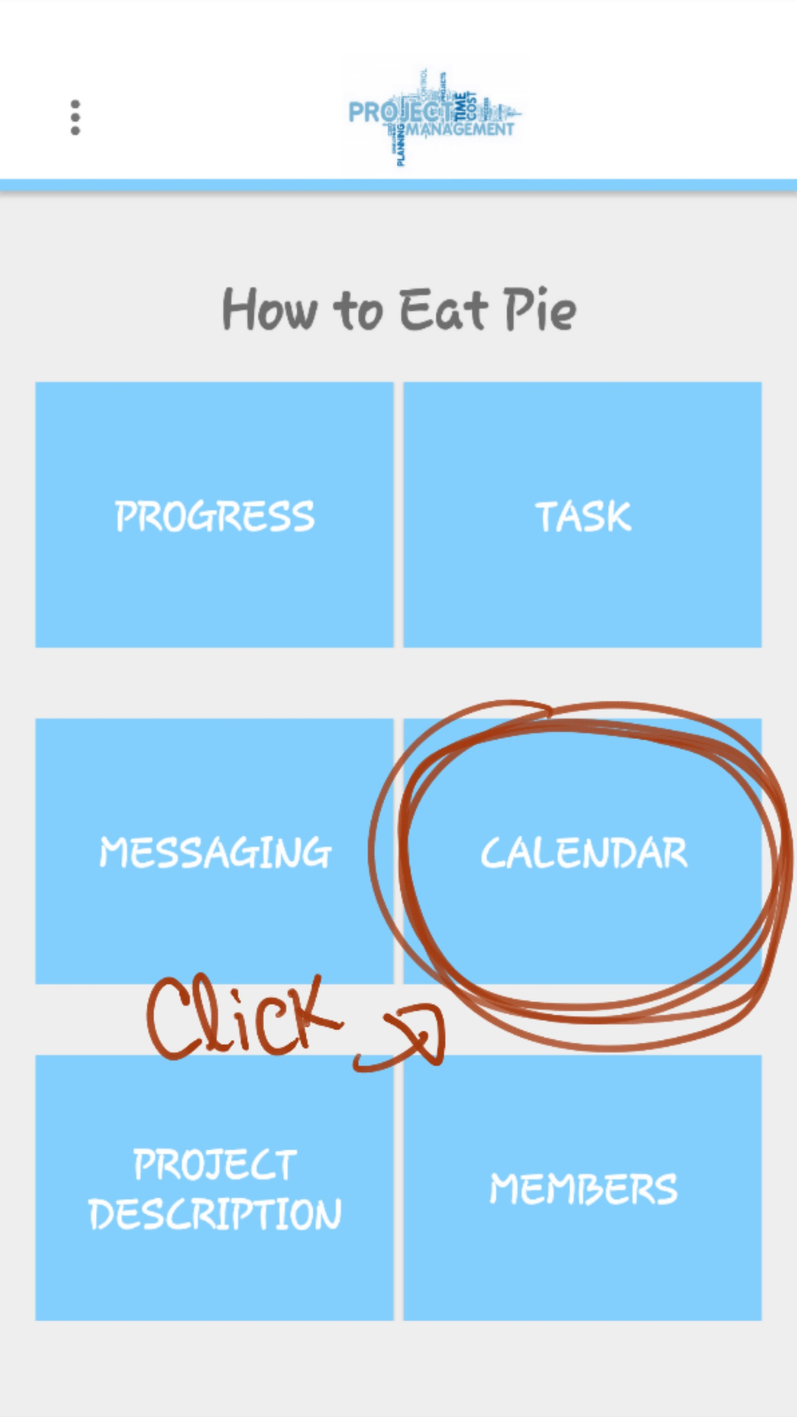

Figure 16: The location of the “CALENDAR” button in the project view

**3.12 View Overall Progress**

To view the overall progress of the specific project you must be logged in and be a part of a created project. Once those requirements are met, click the “PROGRESS” button at the top left hand side in the project view screen. Once clicked, you will be directed to the overall progress screen as shown in Figure 17.

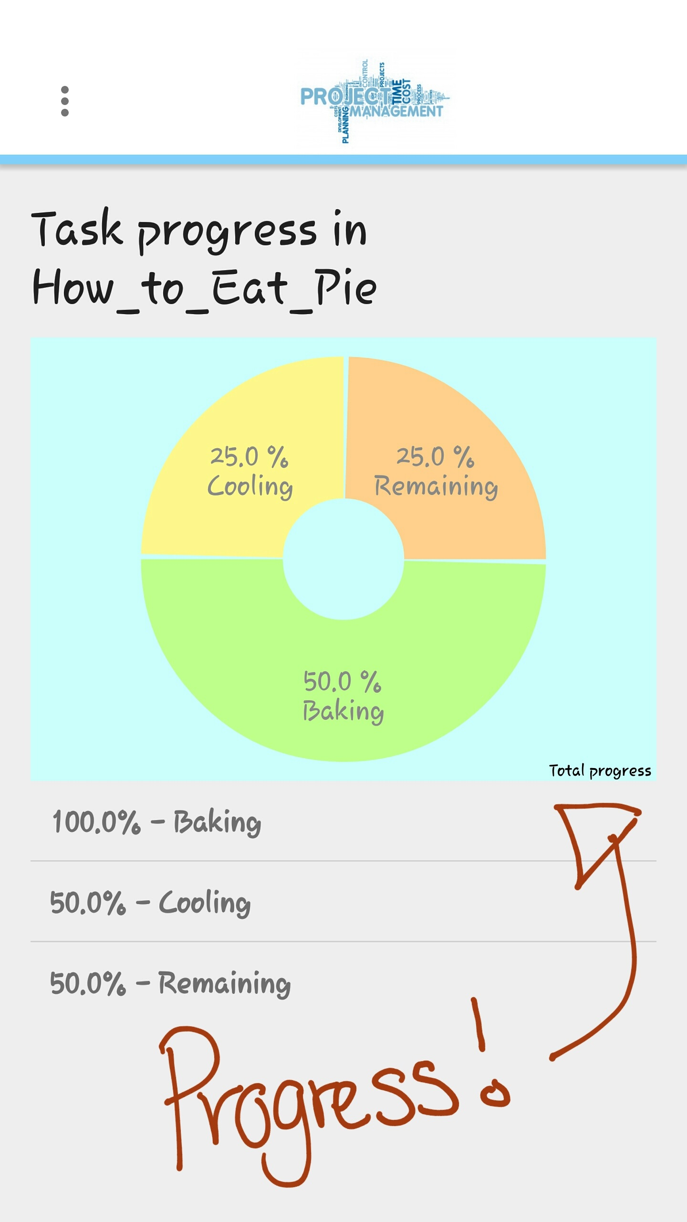

Figure 17: The overall progress of the example project

**3.13 View Individual Progress**

To view individual progress of the specific project or task, you must be logged in and be a part of a created project. Once those requirements are met, click the “MEMBERS” button at the bottom right of the project view screen. You will then be directed to the Member list view screen, select the member you would like to view his/her progress. You then will be directed to that member’s individual progress as shown in Figure 18.

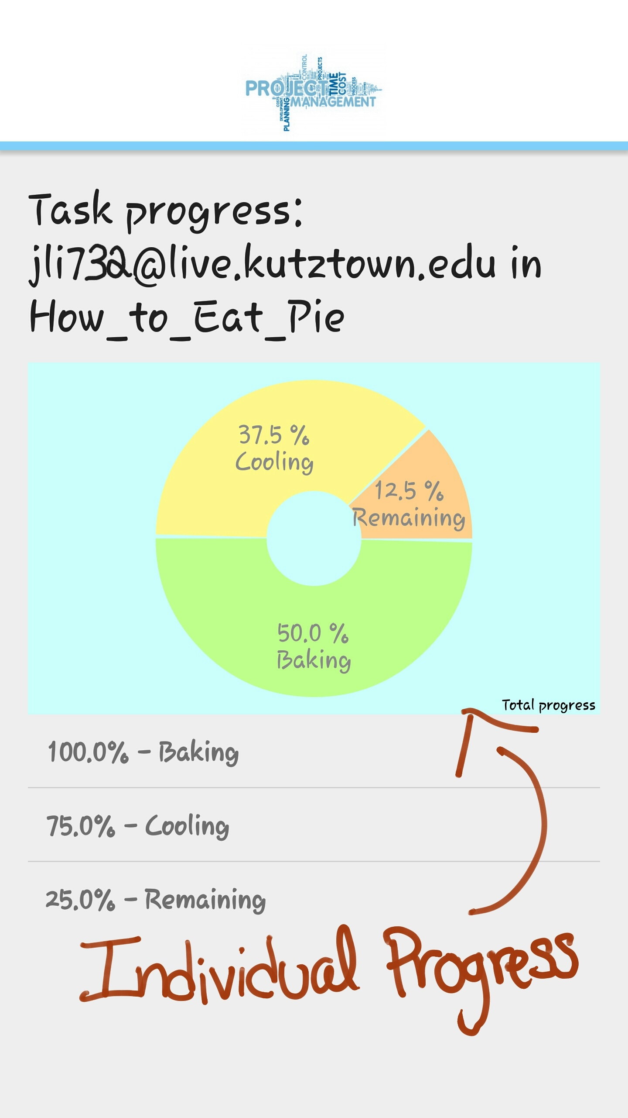

Figure 18: Individual progress of a specific member of the project

**3.14 Choose a Role**

To choose a role in the Project Management app you have to fill out your profile; hit the “  ” and then select the “Profile” option from the dropdown menu. You will then be directed to the profile screen where you fill out all of the available fields as shown in Figure 19. Once done hit the “UPDATE” button at the bottom right hand corner.

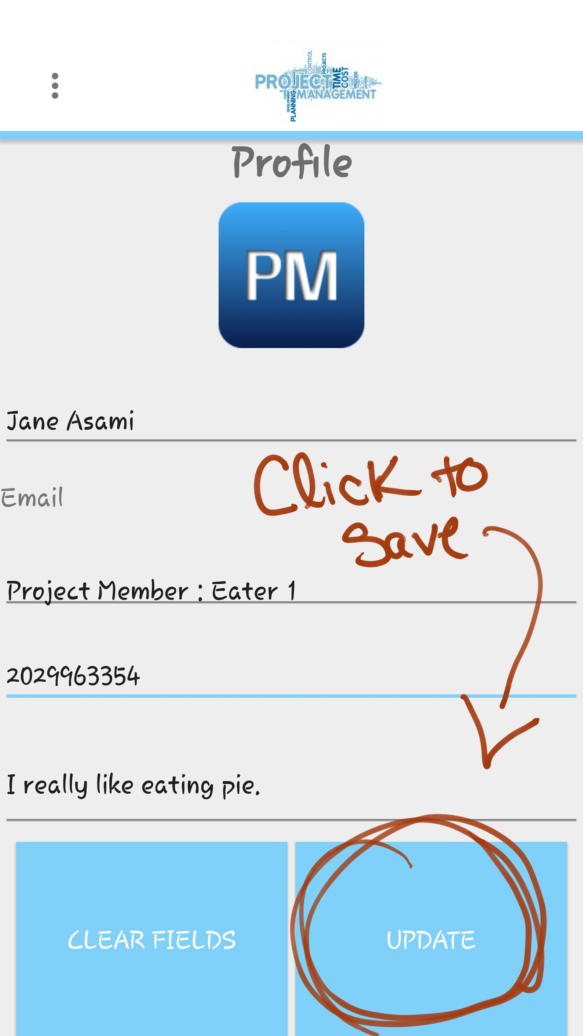

Figure 19: Member Jane has filled her profile and given herself a role

**3.15 Set a Reminder**

To set a reminder of a specific project of a task, you must be logged in and be a part of a created project. Once those requirements are met, Click the “CALENDAR” button at the middle right hand side in the project view screen. You will then be directed to the calendar view specific to your phone. There you will choose a date to view all task due on that date shown in figure 20. If there are task due hit the “SET REMINDER” button to inform the members.

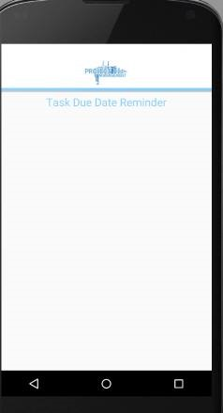

Figure 20: All of the task due on April 29th

**3.16 Message a Member**

To message a member of the specific project you must be logged in and be a part of a created project. Once those requirements are met, Click the “MESSAGING” button at the middle left hand side in the project view screen. Then you will be directed to choose a member to send a message to. Once clicked, you will be directed to the messaging screen as shown in Figure 21. There you will enter a message and hit the “SEND” button to send the message.

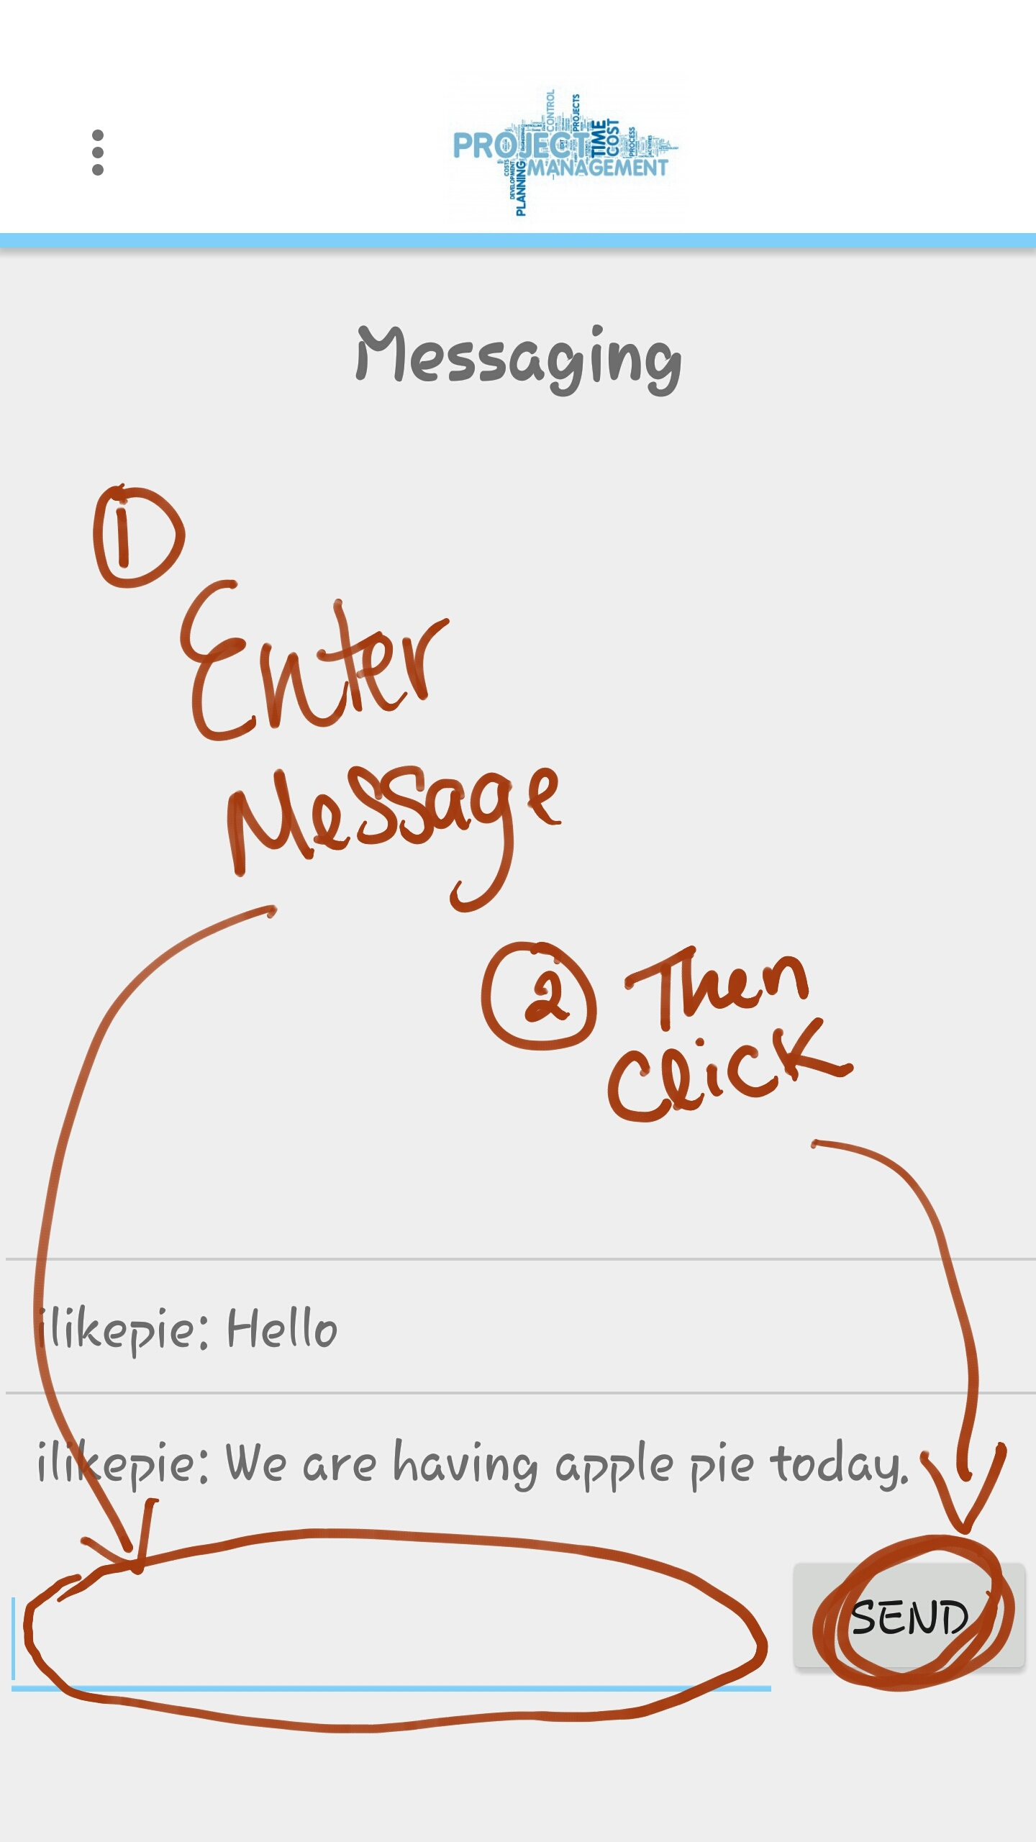

Figure 21: The location of the message field and the SEND button

**3.17 Logout**

To logout of the Project Management app, hit the “  ” and then select the “Logout” option from the dropdown menu as shown in Figure 22.

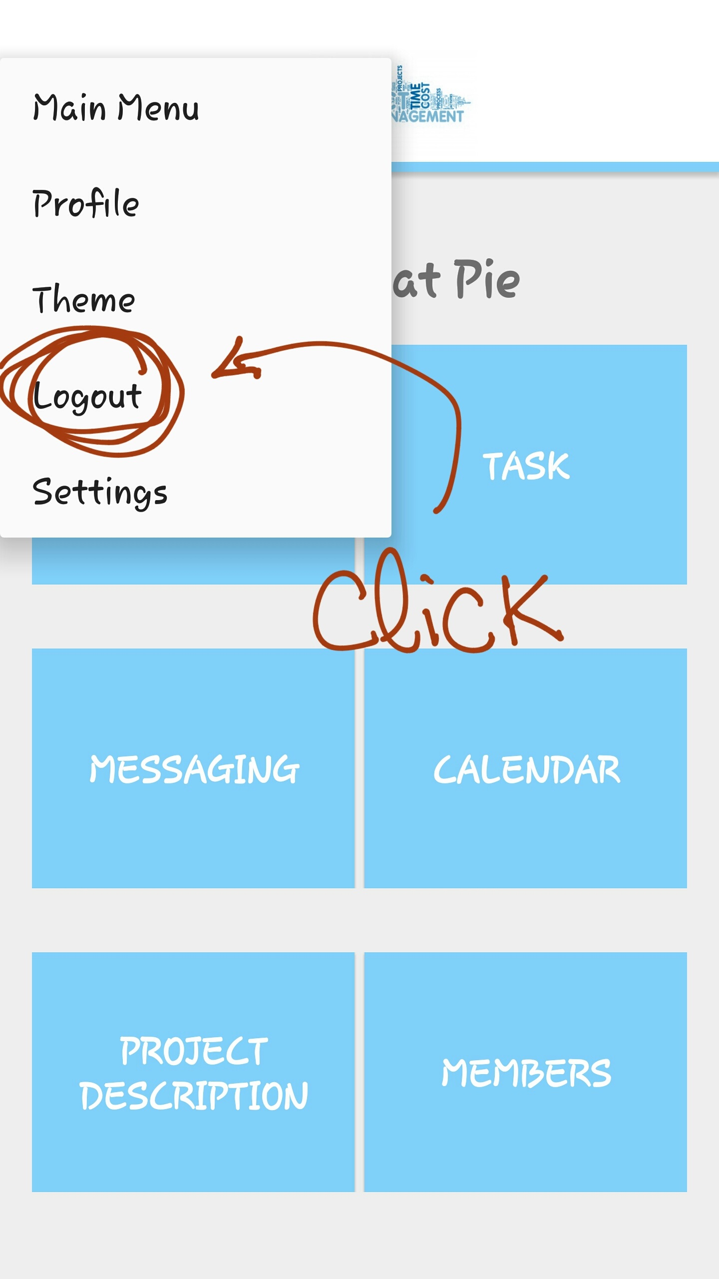

Figure 22: The Logout option in the dropdown menu